Academic Research Division

The aim is to promote academic research on clinically relevant Orthopaedic Issues and to add to the institution’s academic credentials
Introduction of an Academic Research Division (ARD)
Research is one of the most essential factors indicating progress of any faculty of science including Orthopedics. Recent developments in contemporary science and explosion of information technology have provided unprecedented opportunities for refining the art and science of Orthopedics. The current scenario of Indian Orthopedics research is limited to individual effort with some industry driven research. By far the industry driven research have been known to be more rigorous and provide better evidence, however conflict of interest do play a major role. The industry will be interested in research that will directly or indirectly support their cause and may also dictate terms in other matters like conduct of the study, non publication of a negative study and data sharing. Also in Orthopedics the major industry driven research is limited mostly to field of arthroplasty and implant related subjects while the remaining subspecialties hardly receive any industry support. Individual researchers in India have until now managed to perform well, however they face a whole set of difficulties starting from time management, human resources, poor infrastructure and financial issues. Although government and universities should play a role in facilitating and promoting research, their limitation to support specific clinical research is restricting. In other countries a triple helix structure with collaboration among institutions, industry and government exist, however hardly any such collaborations exist in India. The burden and responsibility of performing large scale clinically relevant and patient centered research comes to lie with the academic institutions. However the academic institutes too face the same issues as the individual researchers. A separate academic research division (ARD) will be a step forward towards achieving this goal.
As mentioned, time, infrastructure and human resources have obstructed development of orthopedic research in our country. Even with our vast number and variety of cases, we have been unable to produce organized information and generate quality evidence based studies. The Clinical Research firms conducting trials in orthopedics are limited to either drug trials or an industry driven implant trial. Work of basic sciences and well conducted clinical trials studying the surgical aspects of orthopedics are lacking. Clinical investigators who accept to do research and continue clinical work find it very difficult to balance both fronts.) Intense peer pressure felt by the surgeons, to succeed in respective clinical area, forces them to limit their time and interest for research. An ARD will assist these clinical scientists to carry out the research activities thus off-loading them considerably and providing them adequate time for their clinical work. An academic division at the institute will not only help in providing infrastructure but also can act as focal point for intellectual interactions among the researchers. This will help in generating an environment of ‘Research Awareness’ to evaluate individual research activities and help in developing new projects.
What is an Academic Research Division?
An academic research division (Academic Research Division) will be a facility for performing in-house clinical trials. These are trials which have been designed by the surgeon keeping in mind the clinically relevant issues and will offer a path to improved patient care. The basic aims would be to apply and use research tools to generate evidence for providing best treatment for our patients. Structure of an Academic Research Division– headed by an orthopedic clinical scientist who will be assisted by research coordinators. The head clinical scientist should be an orthopedic surgeon with special training in research front (and) and with understanding of the capabilities and limitations of basic science approaches and research methodology. Primarily the research co-ordinators may or may not be clinicians, but they should be science graduate with a diploma course in Clinical Research. The number of research coordinators may vary according to the volume of work at the institute. The Research Co-ordinator will be assisted by Data Entry Co-ordinators. The Data Entry Co-ordinators are the grass root workers of ARD and qualification of a science graduate with good hold on native languages is ideal for them. A bio-statistician is an integral part of this division and such a requirement should never be discounted. Lastly support of the clinical staff is most important for working of an ARD.
This department would carry out the following functions:-
-designing relevant studies in co-operation with the clinical faculties;
-collection, compilation and maintenance of a digital databank;
-getting ethical clearance from the institutional review board;
-implementation of the study protocols and collection of data;
-analysis of data and publishing the study in a scientific journal;
- teaching the resident doctors and also the faculty members, principles of research methodology and their applications;
-conducting workshops and seminars on research methodology.
With a good hospital information software and radiographic Picture Achieving, Compression and Storage System [PACS], the ARD will be well equipped to carry out all the above mentioned functions. The ARD can also co-ordinate with the administration in setting up inter- department or inter- institute studies.
One of our major limitations is lack of training in research methodology in our grooming years and thus scarcity of Orthopedic Clinical Scientist. Even though it is necessary to undertake postgraduate thesis, most of it is mediocre and hardly any of it gets into printed literature. ARD can turn this limitation into our biggest asset. It can help train the resident doctors in methods of clinical research including designing a study, collecting the data, and understanding the statistical part. This can encourage our students to follow their natural ambitions and curiosity and offer them training and mentoring in research and education. Most importantly ARD will shoulder the responsibility of publishing all the studies performed by the students. This will, in span of few years, create a workforce well trained in research methodology along with skills in orthopedics and also create a body of literature that will be relevant to our clinical practice in India.⁹ Research accomplishments can define a hospital as ‘cutting-edge’, providing an advantage in competitive clinical markets. Finally, academic research will also bring new professional, scientific and clinical opportunities to the faculty working at academic institutes. This will also be very relevant with respect to applicability of the research to our population of patients.

Structure of ARD
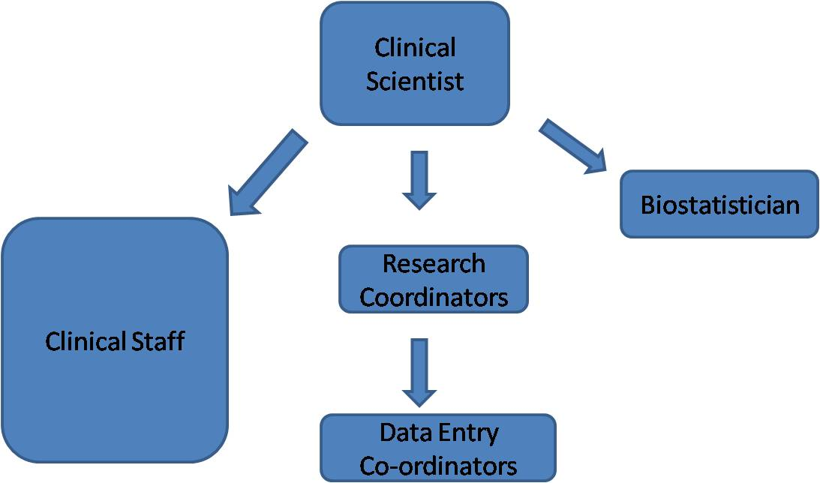

Clinical scientist- Will be provided by the Indian Orthopaedic Research Group and will be a qualified Orthopaedic Surgeon with knowledge of statistics and research Methodology. He will be available for limited time on weekly or fortnightly basis and will supervise the working of the ARD and will also be responsible for setting up new projects, completing projects and submission of the articles
For every Hospital we will require two data entry co-ordinators who will be selected on interview basis. These must be science graduate with short course in clinical research. These will collect compile and retrieve data as per the ongoing projects under ARD
Biostatistician will be provided by the Indian Orthopaedic Research Group.
Clinical staff is all the Orthopaedic Surgeons in the hospital

Technical Support required for ARD
- Place to organize an office
- two desktop computers connected to intranet and internet
- A printer and facility to Xerox clinical data forms

Financial support required for ARD.
A financial agreement will be made between the institution and Indian Orthopaedic Research Group for Payment of Clinical Scientist and data Co-ordinators. Biostatistician will be required to be paid on project basis through the Ortho-Stat Service of IORG.
We suggest a probation period of 3 months after which the ARD should be reviewed and decision regarding its continuation to be finalized.

