REGISTRATION FORM
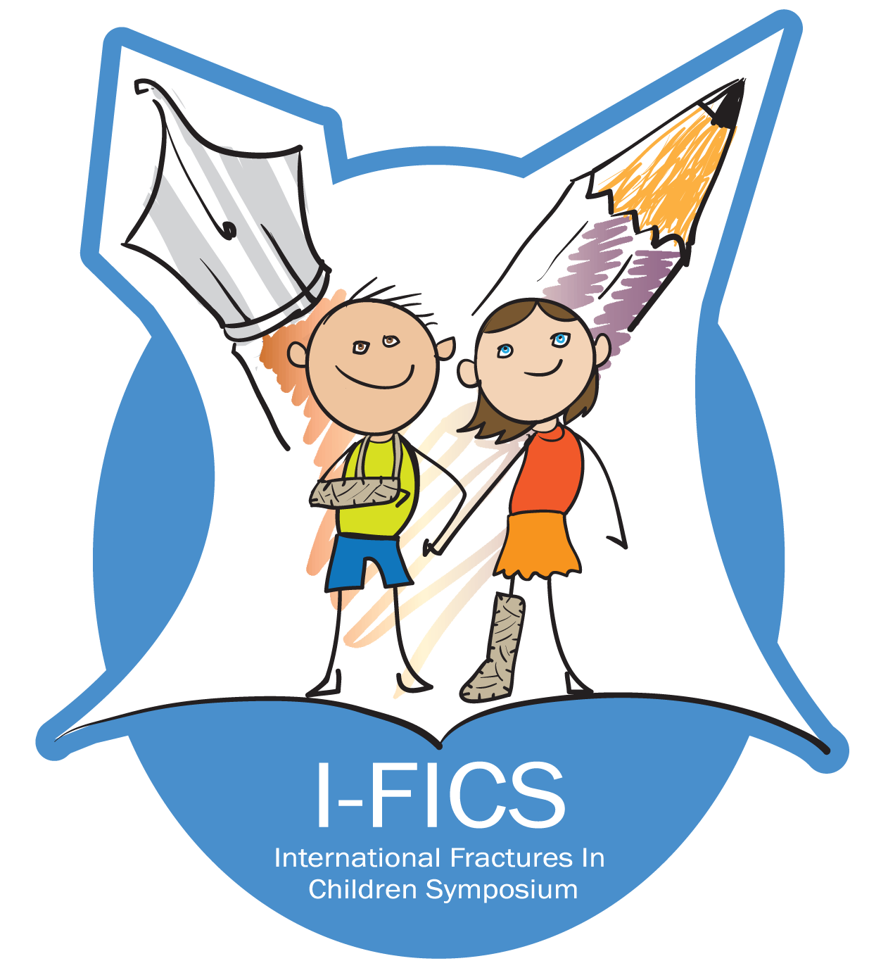 | IFICS 2016  International Fractures In Children Symposium  HOTEL CASPIA, AHMEDABAD  27-28 AUGUST 2016

NAME:
POSTAL ADDRESS:
CITY: STATE: PINCODE:
COUNTRY:
EMAIL:
MOBILE NO: ALTERNATE PHONE NO:
WHATS APP NO:
(please mention your active email ID and mobile number with active whatt’s app account as all future communications will be sent via email, Whatts app, SMS)

Payment Details  Cheque (At par cheques only) / DD drawn on ‘Aadhar Charitable Trust’ - Payable at Ahmedabad | Bank Transfer Details  Aadhar Charitable Trust,  Aandhra Bank ,(0872)Navrangpura  A/c no - 087210100015939  IFSC code- ANDB0000872

Non-residential
Early bird - 31 May 3000 Rs.  1 Jun – 31- July 3250 Rs.  1 August - 20 August 3500 Rs. | Includes conference dinner on Saturday 27 August evening

Residential
Residential package includes Conference fees, All meals including conference dinner & Free wifi
Twin Sharing Basis  2 days 1 night (Check in 27 August)  Early bird - 31 May 6000 Rs.  1 Jun - 31- July 6250 Rs.  1 August - 20 August 6500 Rs. | Single Occupancy  2 days 1 night (Check in 27 August)  Early bird - 31 May 8500 Rs.  1 Jun - 31- July 8750 Rs.  1 August - 20 August 9000 Rs.
3 days 2 nights (Check in 26 August)  Early bird - 31 May 8500 Rs.  1 Jun - 31- July 8750 Rs.  1 August - 20 August 9000 Rs. | 3 days 2 nights (Check in 26 August)  Early bird - 31 May 13000 Rs.  1 Jun - 31 - July 13250 Rs.  1 August - 20 August 13500 Rs.

CONFERENCE SECRETARIATE
Rainbow Superspeciality Hospital & Children’s Orthopedic Hospital, Next to Asia English School, Behind HDFC bank, Opposite Drive In Cinema, Bodakdev, Ahmedabad 380054 Gujarat

